There are four different cloud models that you can subscribe according to business needs:

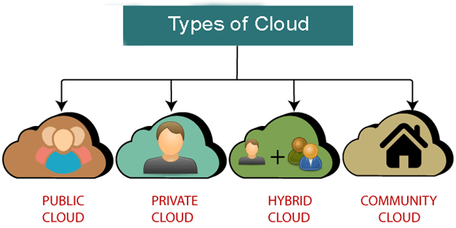

Public Cloud

* Public cloud is **open to all** to store and access information via the Internet using the pay-per-usage method.
* In public cloud, computing resources are managed and operated by the Cloud Service Provider (CSP).
* **Public Cloud** allows systems and services to be easily accessible to general public. The IT giants such as **Google, Amazon** and **Microsoft** offer cloud services via Internet.

**Example:** Amazon elastic compute cloud (EC2), IBM SmartCloud Enterprise, Microsoft, Google App Engine, Windows Azure Services Platform.

The Public Cloud Model is shown in the diagram below.

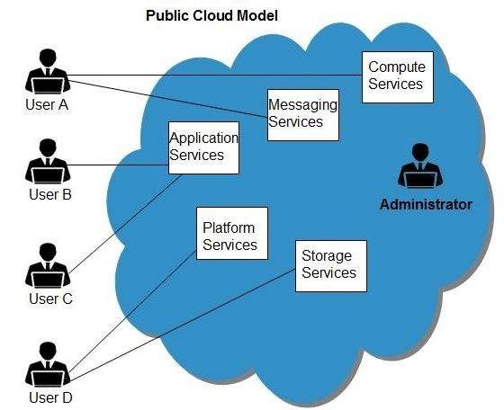

Benefits

There are many benefits of deploying cloud as public cloud model. The following diagram shows some of those benefits:

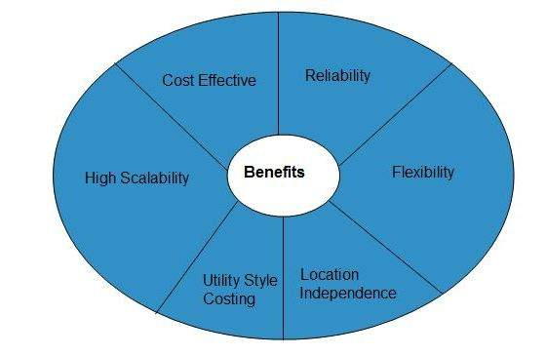

Cost Effective

Since **public cloud** shares same resources with large number of customers it turns out inexpensive.

Reliability

The **public cloud** employs large number of resources from different locations. If any of the resources fails, public cloud can employ another one.

Flexibility

The public cloud can smoothly integrate with private cloud, which gives customers a flexible approach.

Location Independence

**Public cloud** services are delivered through Internet, ensuring location independence.

Utility Style Costing

Public cloud is also based on **pay-per-use** model and resources are accessible whenever customer needs them.

High Scalability

Cloud resources are made available on demand from a pool of resources, i.e., they can be scaled up or down according the requirement.

Disadvantages

Here are some disadvantages of public cloud model:

Low Security

In **public cloud model,** data is hosted off-site and resources are shared publicly, therefore does not ensure higher level of security.

Less Customizable

It is comparatively less customizable than private cloud.

Private Cloud

Private cloud is also known as an **internal cloud** or **corporate cloud**. It is used by organizations to build and manage their own data centers internally or by the third party. It can be deployed using Opensource tools such as Openstack and Eucalyptus.

Based on the location and management, National Institute of Standards and Technology (NIST) divide private cloud into the following two parts-

* On-premise private cloud
* Outsourced private cloud

**Private Cloud** allows systems and services to be accessible within an organization. The Private Cloud is operated only within a single organization. However, it may be managed internally by the organization itself or by third-party. The private cloud model is shown in the diagram below.

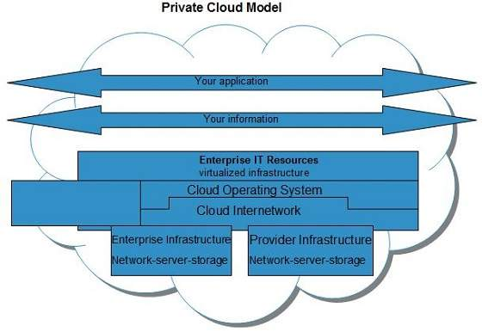

Benefits

There are many benefits of deploying cloud as private cloud model. The following diagram shows some of those benefits:

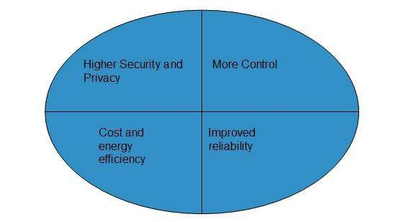

High Security and Privacy

**Private cloud** operations are not available to general public and resources are shared from distinct pool of resources. Therefore, it ensures high **security** and **privacy.**

More Control

The **private cloud** has more control on its resources and hardware than public cloud because it is accessed only within an organization.

Cost and Energy Efficiency

The **private cloud** resources are not as cost effective as resources in public clouds but they offer more efficiency than public cloud resources.

Disadvantages

Here are the disadvantages of using private cloud model:

Restricted Area of Operation

The private cloud is only accessible locally and is very difficult to deploy globally.

High Priced

Purchasing new hardware in order to fulfill the demand is a costly transaction.

Limited Scalability

The private cloud can be scaled only within capacity of internal hosted resources.

Additional Skills

In order to maintain cloud deployment, organization requires skilled expertise.

Hybrid Cloud

**Hybrid Cloud** is a mixture of **public** and **private** cloud. Non-critical activities are performed using public cloud while the critical activities are performed using private cloud.

Hybrid Cloud = Public Cloud + Private Cloud

Hybrid cloud is partially secure because the services which are running on the public cloud can be accessed by anyone, while the services which are running on a private cloud can be accessed only by the organization's users.

Example: Google Application Suite (Gmail, Google Apps, and Google Drive), Office 365 (MS Office on the Web and One Drive), Amazon Web Services.

The Hybrid Cloud Model is shown in the diagram below.

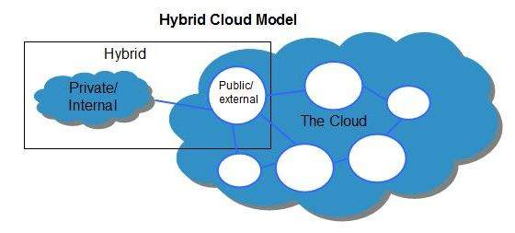

Benefits

There are many benefits of deploying cloud as hybrid cloud model. The following diagram shows some of those benefits:

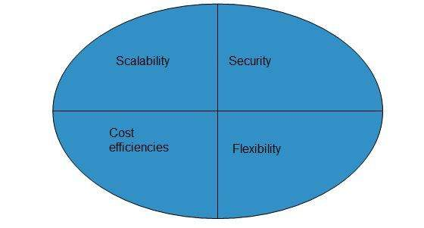

Scalability

It offers features of both, the public cloud scalability and the private cloud scalability.

Flexibility

It offers secure resources and scalable public resources.

Cost Efficiency

Public clouds are more cost effective than private ones. Therefore, hybrid clouds can be cost saving.

Security

The private cloud in hybrid cloud ensures higher degree of security.

Disadvantages

Networking Issues

Networking becomes complex due to presence of private and public cloud.

Security Compliance

It is necessary to ensure that cloud services are compliant with security policies of the organization.

Infrastructure Dependency

The **hybrid cloud model** is dependent on internal IT infrastructure, therefore it is necessary to ensure redundancy across data centers.

Community Cloud

**Community Cloud** allows system and services to be accessible by group of organizations. It shares the infrastructure between several organizations from a specific community. It may be managed internally by organizations or by the third-party, or a combination of them.

. The Community Cloud Model is shown in the diagram below.

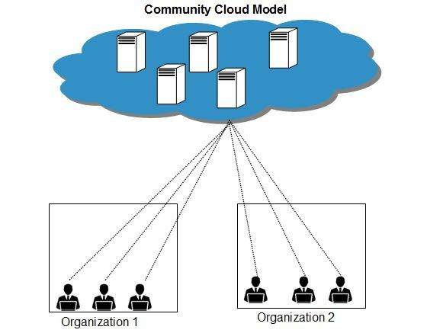

Benefits

There are many benefits of deploying cloud as **community cloud model.**

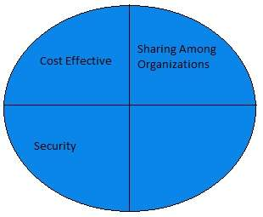

Cost Effective

**Community cloud** offers same advantages as that of private cloud at low cost.

Sharing Among Organizations

Community cloud provides an infrastructure to share cloud resources and capabilities among several organizations.

Security

The community cloud is comparatively more secure than the public cloud but less secured than the private cloud.

Issues

* Since all data is located at one place, one must be careful in storing data in community cloud because it might be accessible to others.
* It is also challenging to allocate responsibilities of governance, security and cost among organizations.

**Example:** Health Care community cloud

Difference between public cloud, private cloud, hybrid cloud, and community cloud -

The below table shows the difference between public cloud, private cloud, hybrid cloud, and community cloud.

|  |  |  |  |  |
| --- | --- | --- | --- | --- |
| **Parameter** | **Public Cloud** | **Private Cloud** | **Hybrid Cloud** | **Community Cloud** |
| **Host** | Service provider | Enterprise (Third party) | Enterprise (Third party) | Community (Third party) |
| **Users** | General public | Selected users | Selected users | Community members |
| **Access** | Internet | Internet, VPN | Internet, VPN | Internet, VPN |
| **Owner** | Service provider | Enterprise | Enterprise | Community |

Public Cloud

* Public Cloud provides a **shared platform** that is accessible to the **general public** through an Internet connection.
* Public cloud operated on the **pay-as-per-use model** and administrated by the **third party**, i.e., Cloud service provider.
* In the Public cloud, the same storage is being used by multiple users at the same time.
* Public cloud is **owned, managed,** and **operated** by businesses, universities, government organizations, or a combination of them.
* Amazon Elastic Compute Cloud (EC2), Microsoft Azure, IBM's Blue Cloud, Sun Cloud, and Google Cloud are examples of the public cloud.

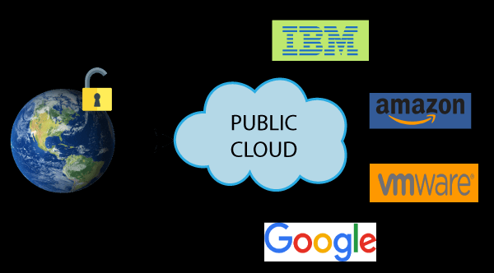

Advantages of Public Cloud

There are the following advantages of public cloud -

1) Low Cost

Public cloud has a lower cost than private, or hybrid cloud, as it shares the same resources with a large number of consumers.

2) Location Independent

Public cloud is location independent because its services are offered through the internet.

3) Save Time

In Public cloud, the cloud service provider is responsible for the manage and maintain data centers in which data is stored, so the cloud user can save their time to establish connectivity, deploying new products, release product updates, configure, and assemble servers.

4) Quickly and easily set up

Organizations can easily buy public cloud on the internet and deployed and configured it remotely through the cloud service provider within a few hours.

5) Business Agility

Public cloud provides an ability to elastically re-size computer resources based on the organization's requirements.

6) Scalability and reliability

Public cloud offers scalable (easy to add and remove) and reliable (24*7 available) services to the users at an affordable cost.

Disadvantages of Public Cloud

1) Low Security

Public Cloud is less secure because resources are shared publicly.

2) Performance

In the public cloud, performance depends upon the speed of internet connectivity.

3) Less customizable

Public cloud is less customizable than the private cloud.

Private Cloud

* Private cloud is also known as an **internal cloud** or **corporate cloud**.
* Private cloud provides computing services to a **private internal network (within the organization)** and **selected users**instead of the general public.
* Private cloud provides a **high level of security** and **privacy** to data through firewalls and internal hosting. It also ensures that operational and sensitive data are not accessible to third-party providers.
* HP Data Centers, Microsoft, Elastra-private cloud, and Ubuntu are the example of a private cloud.

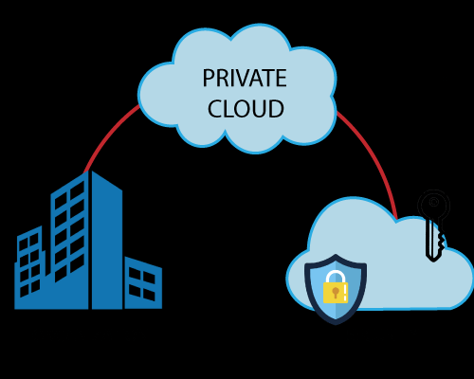

Advantages of Private cloud

There are the following advantages of Private Cloud -

1) More Control

Private clouds have more control over their resources and hardware than public clouds because it is only accessed by selected users.

2) Security & privacy

Security & privacy are one of the big advantages of cloud computing. Private cloud improved the security level as compared to the public cloud.

3) Improved performance

Private cloud offers better performance with improved speed and space capacity.

Disadvantages of Private Cloud

1) High cost

The cost is higher than a public cloud because set up and maintain hardware resources are costly.

2) Restricted area of operations

As we know, private cloud is accessible within the organization, so the area of operations is limited.

3) Limited scalability

Private clouds are scaled only within the capacity of internal hosted resources.

4) Skilled people

Skilled people are required to manage and operate cloud services.

Hybrid Cloud

* Hybrid cloud is a combination of **public and private** clouds.  
  **Hybrid cloud = public cloud + private cloud**
* The main aim to combine these cloud (Public and Private) is to create a unified, automated, and well-managed computing environment.
* In the Hybrid cloud, **non-critical activities** are performed by the **public cloud** and **critical activities** are performed by the **private cloud**.
* Mainly, a hybrid cloud is used in finance, healthcare, and Universities.
* The best hybrid cloud provider companies are **Amazon, Microsoft, Google, Cisco,** and **NetApp**.

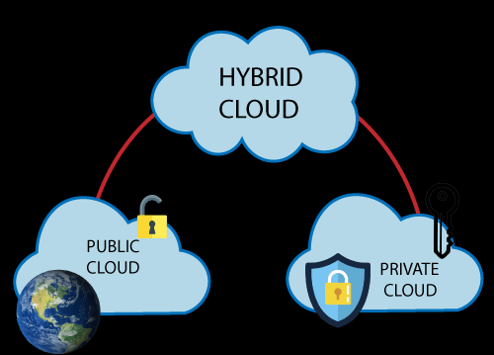

Advantages of Hybrid Cloud

There are the following advantages of Hybrid Cloud -

1) Flexible and secure

It provides flexible resources because of the public cloud and secure resources because of the private cloud.

2) Cost effective

Hybrid cloud costs less than the private cloud. It helps organizations to save costs for both infrastructure and application support.

3) Cost effective

It offers the features of both the public as well as the private cloud. A hybrid cloud is capable of adapting to the demands that each company needs for space, memory, and system.

4) Security

Hybrid cloud is secure because critical activities are performed by the private cloud.

5) Risk Management

Hybrid cloud provides an excellent way for companies to manage the risk.

Disadvantages of Hybrid Cloud

1) Networking issues

In the Hybrid Cloud, networking becomes complex because of the private and the public cloud.

2) Infrastructure Compatibility

Infrastructure compatibility is the major issue in a hybrid cloud. With dual-levels of infrastructure, a private cloud controls the company, and a public cloud does not, so there is a possibility that they are running in separate stacks.

3) Reliability

The reliability of the services depends on cloud service providers.

Community Cloud

Community cloud is a cloud infrastructure that allows systems and services to be accessible by a group of several organizations to share the information. It is owned, managed, and operated by one or more organizations in the community, a third party, or a combination of them.

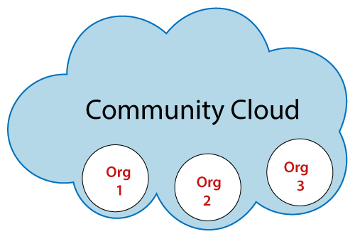

**Example:** Our government organization within India may share computing infrastructure in the cloud to manage data.

Advantages of Community Cloud

There are the following advantages of Community Cloud -

Cost effective

Community cloud is cost effective because the whole cloud is shared between several organizations or a community.

Flexible and Scalable

The community cloud is flexible and scalable because it is compatible with every user. It allows the users to modify the documents as per their needs and requirement.

Security

Community cloud is more secure than the public cloud but less secure than the private cloud.

Sharing infrastructure

Community cloud allows us to share cloud resources, infrastructure, and other capabilities among various organizations.

Disadvantages of Community Cloud

There are the following disadvantages of Community Cloud -

* Community cloud is not a good choice for every organization.
* Slow adoption to data
* The fixed amount of data storage and bandwidth is shared among all community members.
* Community Cloud is costly than the public cloud.
* Sharing responsibilities among organizations is difficult.